Abstract

Company System Project is an essentially software designed to keep track of employee information in any company. It stores informational data of company’s employees, clients, projects and economy. The goal of "Company System" is to create a work centre scheduling system. The Company system project gives managers a better idea of their employees and helps them plan and manage their work hours in order to cut costs and boost productivity. It gives appropriate directions and supervisions for employees and also helps the high level management to make the most out of the company’s resources in an efficient manner. It also secures and manages information that are important to the employees including personal and work-related information. It keeps track of current status including clients, projects, working team and all the needs required for an organization. The project also includes biometric attendance system which is designed intelligently to ensure the lowest errors.

Company System can help your business to be more organized and profitable while better serving customers. It will boost productivity, quick communication, automation and accuracy.

Requirement Analysis

1. Key Stakeholders and End-Users

Company system is sponsored by RichTech IT Solutions and their requirements are:

1. Managing employee information
2. Managing client information and updates
3. Project management in an effective way
4. Overview of complete economy
5. Secured environment
6. Fast and reliable workflow
7. User Friendly interface
8. Categorize requirements
9. Functional requirement

Our company system will offer a better user interface with enhanced features of modern requirements that will help every user interact with the management, colleagues to have a better communication to ensure effective working of the system.

1. Technical requirements

Company System is built with HTML/CSS/Bootstrap, programmed with PHP, JavaScript and Python which makes the project versatile.

C. Transitional Requirements

This Project is robust and portable as it’s programmed in PHP and JS, so it’s easy to add up new features without disturbing other features. This project is platform independent so no matter which platform the user uses, it supports and give the best experience to the End-user.

Waterfall Model

Requirements

A software system that manages all the data regarding employees, clients, projects, and the economy. It generates precise reports, invoices, and other documents.

Design

Software designed in HTML/CSS/Bootstrap, JS, and backend with PHP, Python, and MySQL.

Implementation

1. Login System

2. Employee details

3. Client & Project Management

4. Attendance System

5. Report & Invoice generator

6. Evaluation for Recruitment

7. Economical Stats

8. Project Documentation

Testing

Performing Regression and Beta Testing for each section and feature of the project.

Deployment

Setting up the computers with minimal configuration needs and deploying the software on Cloud.

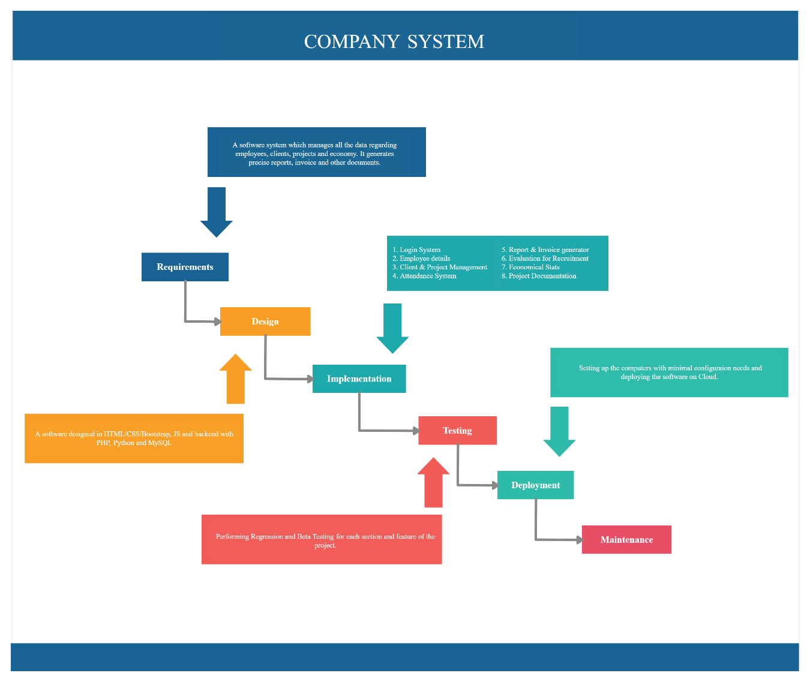

Requirement Traceability Matrix

|  |  |  |  |  |
| --- | --- | --- | --- | --- |
| Id | Sub. ID. | Task name | Task description | Status |
| 1. | 1.1 | Login | Login with suitable privilege | Completed |
| 1. | 1.2 | Forgot Password | Forgot password link (unique) | In progress |
| 1. | 1.3 | Logout | For security reasons we need to log out users | completed |
|  | 2.1 | Add employee into system | Add new employee to the system | Partial completed |
| 2. | 2.2 | View employee details | Monitoring of employee work | Partial completed |
| 3. | 3.1 | Attendance system | Record in-time and out-time of each employee | In progress |
| 3. | 3.2 | Attendance logs | View attendance logs of particular employee with name, id or date | In progress |
| 4. | 4.1 | Add client | Adding client and their projects into the system | Completed |
| 4. | 4.2 | Add project work | Recording complete project description and requirements | Completed |
| 4. | 4.3 | Assign work to employee | Creating a group and assigning employees the project work | Completed |
| 4. | 4.4 | Monitor work progress | Keeping track of the projects in the company | Partially completed |
| 5. | 5.1 | Project documentation | Documentation of ongoing and completed projects | Not started |
| 5. | 5.2 | Generate billing invoice | Generate invoice of completed projects | Not started |
| 6. | 6.1 | Salary Receipt generator | Employees salary receipt | Not started |
| 7. | 7.1 | Company economical stats | Keeping track of all financial related data | Not started |
| 8. | 8.1 | Project system | Monitoring of past and upcoming projects | In progress |
| 8. | 8.2 | Project Archive | Keeping record of notable project work for future references | Not started |
| 9. | 9.1 | Recruitment | Platform for evaluating skills of new candidates. | Partial completed |

Literature Survey

Introduction

Company system is designed to keep track of all workflow of the company. The main aim for this system is to automate most of the manual things and to manage and retrieve data in most efficient way.

Keywords

Project Management, PHP, Bootstrap, HTML/CSS, JavaScript, Cloud, MySQL, Arduino.

Objective

This project will provide features like secured environment, ease workflow, reduce in manual work, charts for better analysing work in project management, financial and employee details. Company system is programmed with PHP and MySQL in the back end which makes it versatile, easy and helps it to run it nearly on any Operating System.

Relevant resources:

1. GitHub
2. Google Scholar
3. StackOverflow
4. GeeksForGeeks
5. PHP Documentation

In today’s world managing data is most essential part for any organization. The main motive of this project is to manage the data and give the best view so that it becomes easy for the employees to manage and complete their work effectively and with ease. This project will help to show the data in summarized manner so that the organization can focus more on the projects and handling their clients. This project makes sure that the time consuming systems will get minimized.